## **The data:**

The National Highway Traffic Safety Administration (NHTSA) reports that driving while texting is six times more dangerous than driving drunk

Drivers who text while driving are 23 times more likely to be involved in a car accident.

Car phone holder market is estimated to be 19.2 billion by 2025

<https://markwideresearch.com/car-phone-holder-market/>

The market will grow at a CAGR of 7.5% throughout this decade

<https://dataintelo.com/report/global-mobile-phone-holder-market/>

According to the Kaiser Family FoundationExternal, kids ages 8-18 now spend, on average, a whopping 7.5 hours in front of a screen for entertainment each day,

After correcting for the number of planned comparisons, neither arm 2 (Phone Mount) nor arm 3 (Commitment Plus Habit Tips) showed significant reductions in handheld phone use relative to control. FHWA https://www.fhwa.dot.gov/publications/research/safety/22057/22057.pdf

FHWA found about 30-35% cars had phone mounts in their 2022 study.

FHWA https://www.fhwa.dot.gov/publications/research/safety/22057/22057.pdf

One study conducted by the Insurance Institute for Highway Safety found that the use of seat belt reminders with an audible chime was associated with a 24% increase in seatbelt use rates among drivers of light passenger vehicles. The study also found that the combination of a seatbelt reminder and a visual warning in the instrument cluster was associated with a 59% increase in seat belt use rates.

A study published in the Journal of Medical Internet Research found that text message reminders with a ding sound improved medication adherence rates among patients with chronic diseases. The study found that patients who received the sound reminder were 1.9 times more likely to take their medication as prescribed compared to those who did not receive the sound reminder. This represents a 90% increase in compliance rates.

Another study published in the Journal of Medical Internet Research found that a smartphone app that included a daily reminder with a sound effect improved compliance with physical activity guidelines among adults. The study found that participants who received the sound reminder were 30% more likely to meet the physical activity guidelines compared to those who did not receive the reminder.

40% reduction in deaths with obnoxious dinging.

Monash University Accident Research Centre. Feasibility of occupant protection countermeasures; Report CR100, Australian Transport Safety Bureau (formerly the Federal Office of Road Safety), Commonwealth Department of Transport; Canberra, Australia. 1992. [Google Scholar] [Ref list]

Other source have claimed 20% increase in seatbelt wearing as ar result of the chimes but this is a hard stat to measures since basically all cars have had a chime and the chiming has changed over time to various degrees of severity. Other types of dinging such as for medicine has increase compliance 60%. The point is dinging is extremely effective.

*A study published in the journal Traffic Injury Prevention found that drivers who used phone mounts were less likely to handle their phones while driving, compared to drivers who did not use phone mounts.*

*Another study published in the journal Accident Analysis & Prevention found that drivers who used phone mounts were less likely to be involved in a crash or near-crash, compared to drivers who did not use phone mounts.*

*An article published by the National Highway Traffic Safety Administration (NHTSA) found that phone mounts may be an effective way to reduce distractions while driving and to help prevent accidents on the road.*

According to pewresearch, the percentage of US adults with cell phones is 97% and the percentage of US adults with smartphones is just under 90%. Just as recently as 2011 those figures were 83% and 35% respectively. For those who make 75k a year or more, those figures are 100% and 96% respectively as of 2021.

Data regarding accidents is very difficult to draw conclusions from. Many accidents are not reported to an officer. Of those that are reported by an officer and where a crash report is filed, the definitions, classifications, standards, and fields of the report vary greatly. pewresearch

“Cars travel the length of a football in 5 seconds when traveling at a mere 55mph”

“An NSC report found that no state fully captures the data required by government and traffic safety organizations to understand the real causes of crashes”

“Twenty-six states lack fields to capture texting”

-<https://injuryfacts.nsc.org/motor-vehicle/motor-vehicle-safety-issues/distracted-driving/data-details/> for both.

This as well as non-response bias and response bias makes for a very limited understanding of the role of cellphones in car crashes.

“The percent of fatal distraction-affected crashes involving cell phone use in 2020 was 14.0% compared to 15.9% in 2019.”

The National Safety Council reports that cell phone use while driving leads to 1.6 million crashes each year.

National Safety Council (NSC), cell phone use is a factor in about 27% of all car crashes in the USA

The number of fatal car crashes in the US involving cell phones was 395 making up roughly 14% of fatal car crashes.

Total number of non-fatal car crashes involving cell phone use was 20,527. Other non-fatal car crashes involving distracted driving not involving cell phones was 266,466. Property damage only crashes involving cell phone use was 40,166. Other PDO crashes not involving cell phones were 656,173. These figures are from NSC data from 2019.

“The percentage of drivers holding cell phones to their ears while driving decreased from 3.2 percent in 2018 to 2.9 percent in 2019 (Figure 1 and Table 1).

This translates to an estimated 432,995 passenger vehicle drivers holding cell phones

to their ears while driving at a typical daylight moment in

2019” -data from NOPUS. Only including talking on the phone with the phone to their ear. Does not include other types of phone usage.

“Nearly 3,000 people are killed on U.S. roads every year in distracted driving crashes, the federal government reports. Cell phone use is a common driver distraction.” -NSC

“Sixty-seven percent of those surveyed by NSC said they felt they were at risk because another driver was distracted by technology. Yet, only 25% said their own distraction from technology was putting others at risk. In part, this "not me" attitude remains prevalent because people believe they are better drivers than those around them.” - NSC

**“Cell Phone Crashes are Under-reported” -NSC**

“According to NHTSA, in 2015 about 7% of drivers were observed to be distracted by cell phones at any moment. In addition, drivers use hands-free devices and voice features that are difficult to observe.” Aka these numbers are low ball estimates from what could be seen and surmised from viewing in the vehicle through the window. This translates to roughly 1,045,160 at any given daylight moment.

228.2 million licensed drivers in the United States.

“About 25% of drivers would be willing to use vehicle and phone voice features to read

or post to social media while driving.” from NSC survey

“NSC found that driver cell phone use was recorded as a factor in fatal crashes only about half the time, even when drivers admitted phone use to police. “ -from NSC 2013 report

“You are four times as likely to crash when using a cell phone while driving. Employers are being held liable up to $25 million for employee crashes, even when employees use hands-free devices.”

**“On-the-job crashes are costly to employers, incurring costs of more than $24,500 per property damage crash and $150,000 per injury crash.”**

“27% of crashes in 2013 involved drivers using cell phones, including 1.2 million crashes where drivers were talking on cell phones and a minimum of 341,000 crashes where drivers were texting”

“11 teen deaths EVERY DAY” – Ins. Institute for Hwy Safety Fatality Fact

“Combining this observational data with self-reported data on hand-held and hands-free phone use, the federal government estimates that 7.9 percent of drivers were using a hand-held or hands-free cellphone during any moment of the day.”

“Apple released its Do Not Disturb While Driving feature in the fall 2017. IIHS conducted a nationally representative survey of iPhone owners and found that only about 1 in 5 had the feature set to activate automatically when they drive”

“Early analyses by HLDI found that collision claims either didn’t change or went up with hand-held phone bans (Trempel et al., 2011) and texting bans (HLDI, 2010).”

“America’s insurers have long been at the front lines of historic safety advancements like seat belts and airbags; helping teens develop responsible habits from the moment they begin to drive is the key to creating a generation of safe drivers and safer roadways for all Americans.”

- APCIA a very good potential future partnership

“In a 2018 study, the Insurance Institute for Highway Safety (IIHS) found that more drivers today are “manipulating” their phones while driving—performing such handheld activities as dialing, texting, accessing websites, entering destinations, and choosing music. The IIHS said this increased the risk of a fatal crash by an estimated 66 percent and contributed to more than 800 crash fatalities on US roads in 2017”

“visual-manual cell phone interaction:

• Tripled drivers’ odds of involvement in a road departure crash.

• Increased drivers’ odds of rear-ending the vehicle ahead by more than a multiple of seven.

The association between cell phone conversation alone and crash involvement was not

statistically significant.” -AAA 2018 report

“Based on its observations of nearly 12,000 real-world drivers in Northern Virginia, IIHS estimates the number of drivers manipulating cell phones increased by 57 percent from 2014 to 2018.”

“Motor vehicle crashes are the second leading cause of death for U.S. teens.” Depending on the gender and age category sometimes the leading cause of death. Data from CDC

“A quarter of teens respond to a text message once or more every time they drive. Twenty percent of teens and 10 percent of parents admit that they have extended, multi-message text conversations while driving.” idrivesafely.com

“38% admitted to driving and texting at least once from the previous month” NSC

“Research commissioned by FMCSA shows that the odds of being involved in a safety-critical event (e.g., crash, near-crash, unintentional lane deviation) are 6 times greater for CMV drivers who engage in dialing a mobile phone while driving than for those who do not.”

“In similar research commissioned by FMCSA, the odds of being involved in a safety-critical event (e.g., crash, near-crash, unintentional lane deviation) are 23.2 times greater for CMV drivers who text while driving than for those who do not.”

“The online AAA survey revealed the following: More than half of drivers (51 percent) admitted they text and/or email while alone in the vehicle”

Study after study has shown that using a phone while driving can be dangerous. But although some safety advocates say you shouldn’t use a phone at all when you’re behind the wheel, that’s not realistic, considering that smartphones—with their integrated digital assistants—have become the go-to device for many people to get directions, play audio, contact others, and obtain information. A phone can also be your most important aid in an emergency. And if your car is operating as a ride-share vehicle, using the services’ apps is an integral part of doing business. The key is to minimize unnecessary phone usage and to use your phone as safely as possible when you must. We have some advice.

***“According to the most recent year of data from the U.S. Centers for Disease Control and Prevention, the total economic cost of vehicle accidents – including the cost of medical care and productivity losses – was over $75 billion.”***

So important for the SBIR and grants in general!!!!!!!!!

“Out of all large truck-related crash deaths, occupants of passenger vehicles potentially involved in the accidents accounted for 2,797 fatalities (68%). On the other hand, occupants of the trucks accounted for 17%, that is, 683 fatalities, while only 14% of all fatalities were noted among pedestrians, bicyclists, and motorcyclists involved in such big truck vehicle accidents (580 deaths).” 2017 IIHS policyadvice.net

“Up to 74.9% of truck accident cases involving a collision with another vehicle in transport have been fatal” CDL knowledge policyadvice.net

“There were 4,102 deaths in truck wrecks in 2017, showing a 52% increase since 2009” - National Highway Traffic Safety Administration — FARS

“94 percent of drivers support a ban on texting while driving.” NSC

“1 out of every 4 car accidents in the United States is caused by texting and driving.” NSC

“In over 90 percent of crashes, the critical reason for the crash is driver behavior.” FHWA

“Truckers are 5 times more likely to die on the job than the average worker” BLS

“Penalties can be up to $2,750 for drivers and up to $11,000 for employers who allow or require drivers to use a hand-held communications device while driving.”

Fmcsa

“A mounted phone is acceptable as long as it is mounted close to the driver” FMCSA

What is the definition of using a mobile telephone?

The use of a hand-held mobile telephone means:

• Using at least one hand to hold a mobile phone to make a call;

• Dialing a mobile phone by pressing more than a single button; or

• Reaching for a mobile phone in a manner that requires a driver to maneuver so that he or she is no longer in a seated driving position, restrained by a seat belt.

FMCSA

A single touch is allowed while driving” for answering, initiation, or terminating calls. Speakerphone is acceptable too FMCSA

“All drivers use phones for sound, navigation, sleep stops, calls etc” ???

**Used in PP:**

**Though they date back to the 1800s, seat belts were used by just 10% of Americans as recently as 1980. However, general education and awareness have improved over the years, and recent polling by the National Highway Traffic Safety Administration (NHTSA) shows that national seat belt use was at 90.7% by 2019.**

**Of the more than 37,000 people who lost their lives in 2017 motor vehicle crashes, almost half were not wearing seat belts as advised. That year, an estimated 2,549 drivers could have found their way home to their loved ones had they buckled up.**

“The 2019 Distracted Driving and Social Media Report from DriversEd.com found 55% of U.S. drivers check social media while driving.” idrivesafely.com

“Motor vehicle crashes are the No. 1 cause of work-related deaths and account for 24% of all fatal occupational injuries”

“Juries are now awarding huge sums related to accidents; looking just at trucking industry verdicts

of over $1M, the average size of awards increased by nearly 1,000 percent from 2010 to 2018. These are verdicts that can force a medium-sized firm into bankruptcy.”

“Motor vehicle fatality is the leading cause of accident death among teenagers, representing over one-third of all deaths to teenagers.” CDC

“In NETS’ most recent Cost of Motor Vehicle Crashes report, a non-fatal injury crash that involves distracted driving while on the job costs employers an average of $100,310 per accident. This decreases to $6,417 when the crash occurs off-the-job.”

“According to NETS, distracted driving costs employers $18.8B a year – almost $10B more per year than speeding, alcohol, or not wearing a seatbelt. In fact, since NETS’ 2015 benchmark report, the cost of distracted driving crashes has increased by 129%, vastly outpacing other driving-related safety related risks.”

“According to NHTSA, in 2015 about 7% of drivers were observed to be distracted by cell phones at any moment. In addition, drivers use hands-free devices and voice features that are difficult to observe.” Aka these numbers are low ball estimates from what could be seen and surmised from viewing in the vehicle through the window. This translates to roughly 1,045,160 at any given daylight moment.

## **Diagrams:**

Zippia:

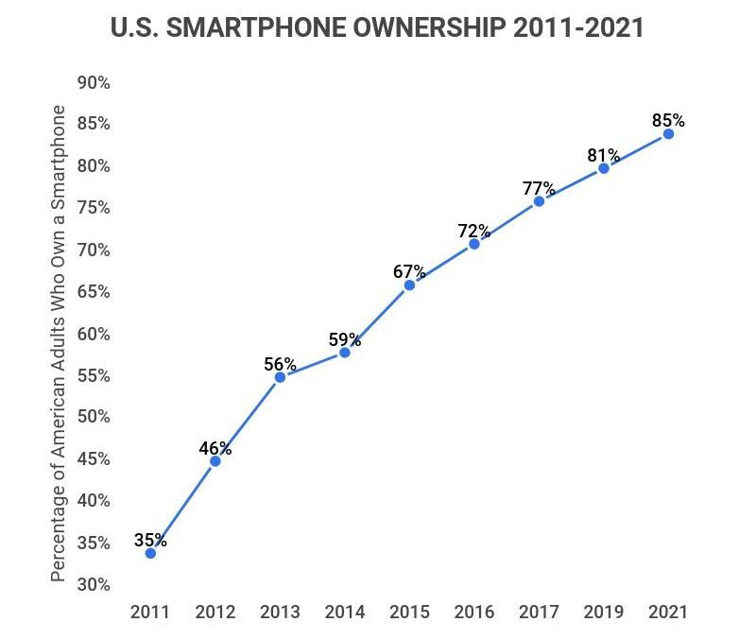

This illustrates the rise of smartphone use and to reiterate that this is still a brand new problem and not a legacy problem. Smartphone use was well under 50% just as recently as 2012.

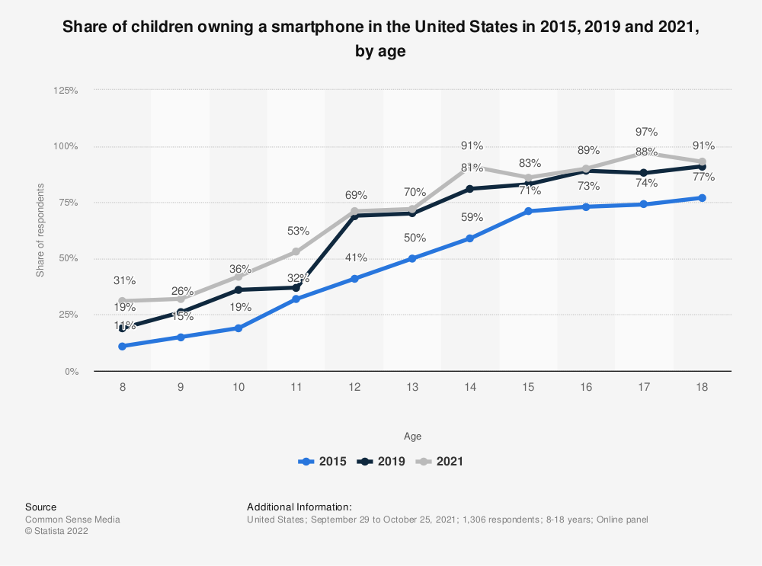

Common Sense Media. (March 23, 2022). Share of children owning a smartphone in the United States in 2015, 2019 and 2021, by age [Graph]. In *Statista*. Retrieved March 27, 2023, from <https://www-statista-com.ezproxy.callutheran.edu/statistics/1324262/children-owning-a-smartphone-by-age-us/>

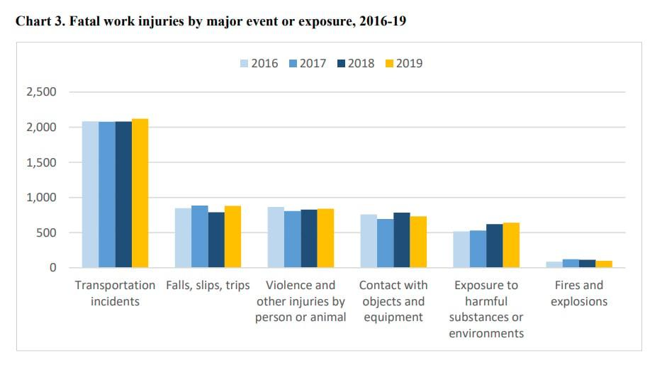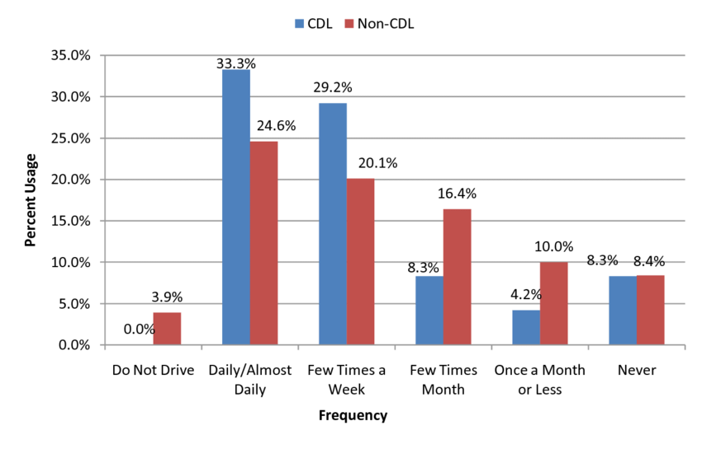Old data from 2011. From researchgate..could not find better data and I looked a lot:

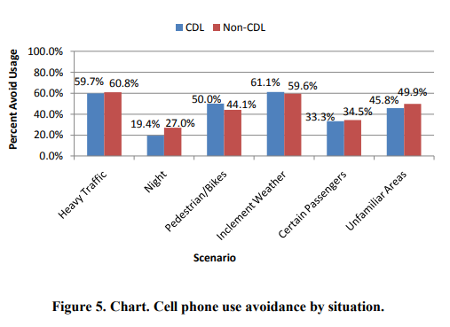

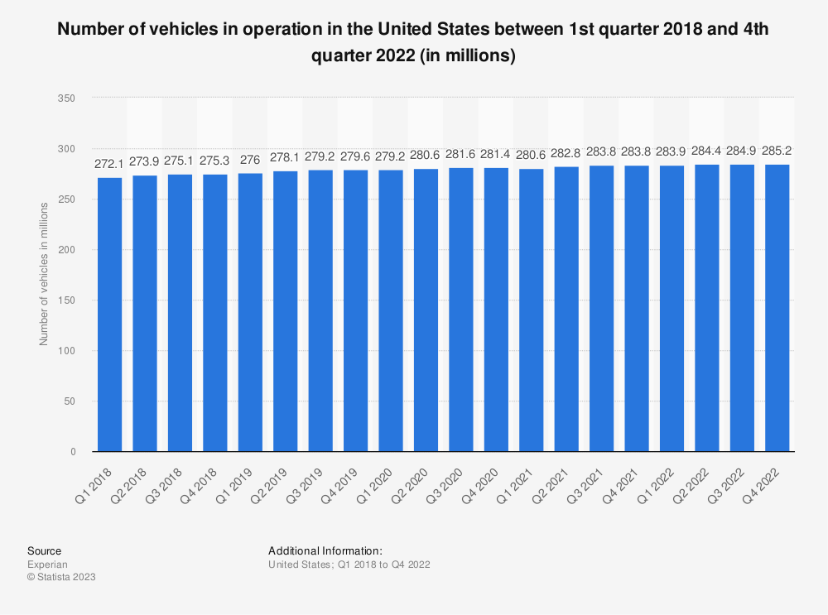

Experian. (January 31, 2023). Number of vehicles in operation in the United States between 1st quarter 2018 and 4th quarter 2022 (in millions) [Graph]. In *Statista*. Retrieved March 27, 2023, from [https://www-statista-com.ezproxy.callutheran.edu/statistics/859950/vehicles-in-operation-by-quarter-united-states/\](https://www-statista-com.ezproxy.callutheran.edu/statistics/859950/vehicles-in-operation-by-quarter-united-states/%5C)

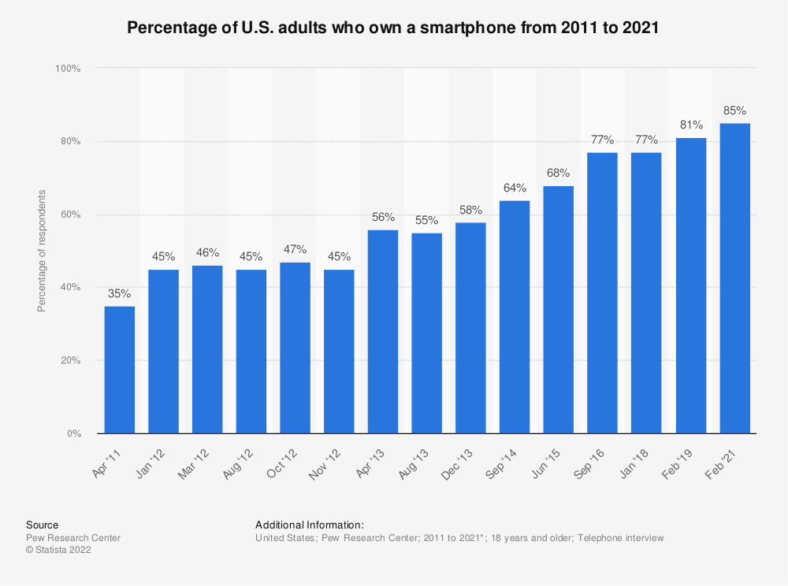

Pew Research Center. (April 7, 2021). Percentage of U.S. adults who own a smartphone from 2011 to 2021 [Graph]. In *Statista*. Retrieved March 27, 2023, from https://www-statista-com.ez

proxy .callutheran.edu/statistics/219865/percentage-of-us-adults-who-own-a-smartphone/

II.

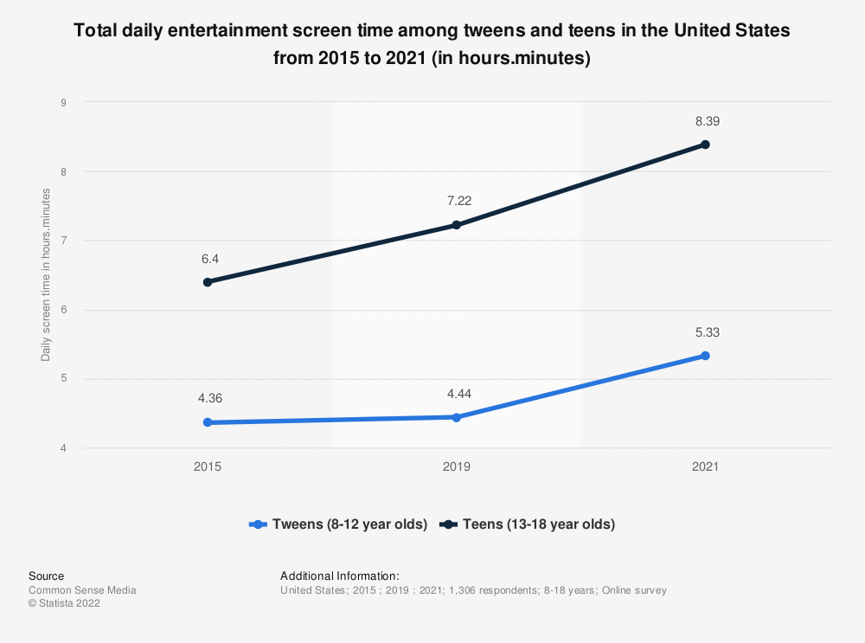

Common Sense Media. (March 23, 2022). Total daily entertainment screen time among tweens and teens in the United States from 2015 to 2021 (in hours.minutes) [Graph]. In *Statista*. Retrieved March 26, 2023, from https://www-statista-com.ezproxy.callutheran.edu

/statistics/1312086/total-daily-entertainment-screen-time-tweens-teens-us/

III.



Experian. (January 31, 2023). Number of vehicles in operation in the United States between 1st quarter 2018 and 4th quarter 2022 (in millions) [Graph]. In *Statista*. Retrieved March 27, 2023, from https://www-statista-com.ezproxy.callutheran.edu/statistics/859950/vehicles-in-operation-

by-quarter-united-states/

IV.

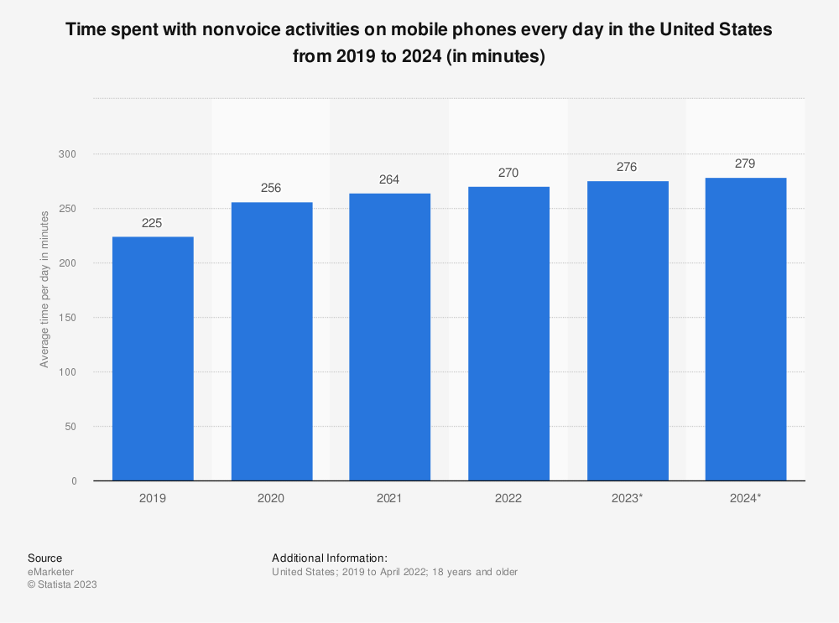

eMarketer. (June 9, 2022). Time spent with nonvoice activities on mobile phones every day in the United States from 2019 to 2024 (in minutes) [Graph]. In *Statista*. Retrieved March 27, 2023, from https://www-statista-com.ezproxy.callutheran.edu/statistics/1045353/mobile-

device-daily-usage-time-in-the-us/?locale=en

V.



Common Sense Media. (March 23, 2022). Share of children owning a smartphone in the United States in 2015, 2019 and 2021, by age [Graph]. In *Statista*. Retrieved March 27, 2023, from https://www-statista-com.ezproxy.callutheran.edu/statistics/1324262/children-owning-a-smartphone-by-age-us/

VI.

[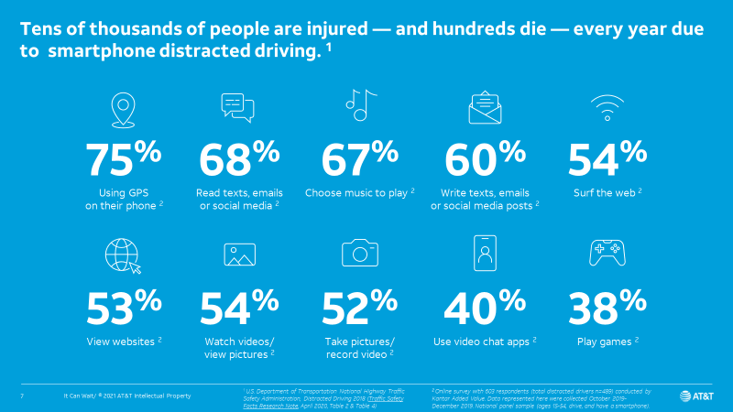](https://www-statista-com.ezproxy.callutheran.edu/statistics/1312086/total-daily-entertainment-screen-time-tweens-teens-us/*)

Common Sense Media. (March 23, 2022). Total daily entertainment screen time among tweens and teens in the United States from 2015 to 2021 (in hours.minutes) [Graph]. In *Statista*. Retrieved April 18, 2023, from https://www-statista-com.ezproxy.callutheran.edu/statistics

/1312086/total-daily-entertainment-screen-time-tweens-teens-us/

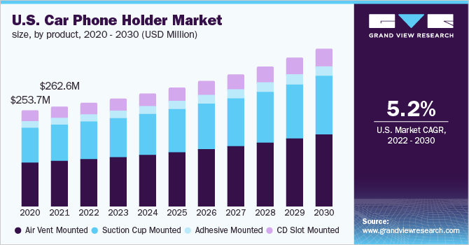

About 300 million per year in the 2025

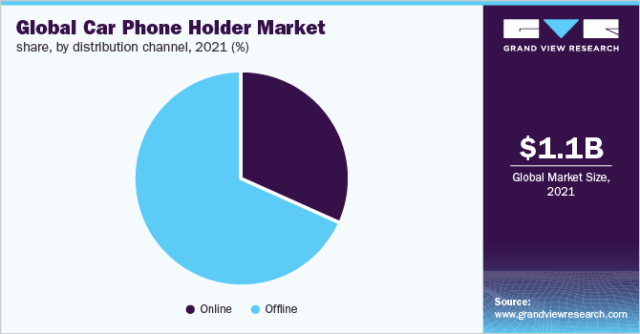

<https://www.grandviewresearch.com/industry-analysis/car-phone-holder-market-report>

